SMART COMMUNITY HEALTH MONITORING AND EARLY WARNING SYSTEM
A PROJECT BASED LEARNING (PBL) REPORT
Submitted by
MANYA SAIPRADEEP - 2104251040551
POOJITHA R -2104251040688
Submitted in partial fulfilment of the requirements for the Project-Based Learning component of Machine Learning

BACHELOR OF ENGINEERING
in
COMPUTER SCIENCE AND ENGINEERING

CHENNAI INSTITUTE OF TECHNOLOGY, CHENNAI
(Kanchipuram District)

Under the guidance of
Mrs. DIVYA M R
M.E, Assistant Professor, Department of CSE




BONAFIDE CERTIFICATE
This is to certify that the Project–Based Learning report titled "Smart Community Health Monitoring and Early Warning System for Water-Borne Diseases in India" is a Bonafide record of work carried out by Manya Saipradeep (2104251040551) and Poojitha R (2104251040688) of the Department of Computer Science and Engineering, Chennai Institute of Technology, as part of the continuous, mentor–guided Project-Based Learning (PBL) component of the Machine Learning course during the academic year 2026–2027 under my supervision.

SIGNATURE  Dr. S. Pavithra S, M.E., Ph.D.  Professor and Head,  Dept. of Computer Science and Engineering  Chennai Institute of Technology,  Chennai – 69. | SIGNATURE  Mrs. Divya M R  MENTOR  M.E., Assistant Professor  Dept. of Computer Science and Engineering  Chennai Institute of Technology,  Chennai – 69.

Submitted for the final review held on …………………….

External Examiner Internal Examiner
DECLARATION
We jointly declare that the PBL report on "Smart Community Health Monitoring and Early Warning System for Water-Borne Diseases in India" is the result of original work done by us and best of our knowledge, similar work has not been submitted to "ANNA UNIVERSITY, CHENNAI" for the requirement of Degree of BACHELOR OF ENGINEERING. This PBL report is submitted on the partial fulfilment of the requirement of the award of Degree of COMPUTER SCIENCE AND ENGINEERING.

Signature

Manya Saipradeep (2104251040551)
Poojitha R (2104251040688)

Place: Chennai
Date:

ACKNOWLEDGEMENT
We would like to express our sincere gratitude to our Chairman,SHRI. P. SRIRAM, for providing us with an excellent infrastructure and environment to carry out this Project-Based Learning work.
We are extremely grateful to our Principal, Dr. A. RAMESH, M.E., Ph.D., for his support and encouragement throughout the course of this project.
We wish to express our sincere thanks to our Dean, Dr. V. SRINIVASA RAO, M.E., Ph.D., for his valuable guidance.
We are deeply indebted to our Head of the Department, Dr. S. PAVITHRA S, M.E., Ph.D., Department of Computer Science and Engineering, for her constant support and encouragement in carrying out this project.
We would like to thank our Project Co-ordinator and Faculty Mentor, Mrs. DIVYA M R, M.E., Assistant Professor, Department of Computer Science and Engineering, for mentoring this project across every review cycle of the PBL - from shaping the driving question in the early weeks to insisting the final model be tested honestly, with negative and rejected experiments documented rather than hidden.
We also thank our Class Advisors for their continuous support and encouragement throughout this Project-Based Learning component.

MANYA SAIPRADEEP (2104251040551)
POOJITHA R (2104250140688)

ABSTRACT
Water-borne diseases such as cholera, typhoid, and acute diarrhoeal illness remain a major public health burden across India, worsened by inconsistent water-quality surveillance and monsoon-driven contamination. This project builds a two-module early-warning system inspired by the Smart India Hackathon problem statement SIH25001. Module B.1 predicts water contamination risk from lab water-quality parameters using a Random Forest classifier trained on the Kaggle water-potability dataset (3,276 samples), reaching 66.8% accuracy and an F1-score of 0.452. Module B.2 predicts district-level disease-outbreak risk using only weather and surveillance-reporting patterns - deliberately excluding case-history shortcuts - by merging real Integrated Disease Surveillance Programme (IDSP) records with historical district-level weather data across 439 Indian districts.
Module B.2 forecasts a district's outbreak risk one month ahead, using only information available from the preceding month, so the prediction never relies on data it could not actually have at the time. Random Forest, XGBoost and EasyEnsemble were compared using GridSearchCV, and EasyEnsemble was selected as the final model, reaching 76.2% accuracy, 28.5% precision, 56.3% recall, an F1-score of 0.379, and a ROC-AUC of 0.766 on real, unseen data. This model catches more than half of real outbreaks in advance while keeping the system practical to run and easy to explain to non-technical users. Both modules are served through an interactive Streamlit dashboard that combines their outputs into a single Combined Risk Summary, alongside historical-record comparison and seasonal trend visualisation.
The reported results were verified with independent diagnostic checks (Chapter 6) to confirm the model is learning genuine patterns rather than noise, and the report documents the system's current scope and limitations plainly rather than only its strengths.
Keywords: water-borne disease, early warning system, class imbalance, EasyEnsemble, precursor-based prediction, public health monitoring

PBL COURSE AND TEAM DETAILS
Field | Details
Course | Machine Learning - Project-Based Learning (PBL)
Faculty Mentor | Mrs. Divya M R, Assistant Professor
Section / Team No. | M/10
PBL Duration | Week 1 - Week 12 (14 July 2026 - 8 September 2026)
Review Cycles Completed | Review 0: 21 July 2026 Review 1 : 18 August 2026
Project Track / Domain | Healthcare / Public Health Surveillance - Machine Learning

Team Roles and Responsibilities
Name | Register No. | Role | Primary Responsibility
Poojitha R | 2104251040688 | Team Member | Dataset acquisition and cleaning, district-name normalisation, feature engineering, exploratory analysis, model training and evaluation
Manya Saipradeep | 2104251040551 | Team Member | Model comparison and tuning (GridSearchCV), diagnostic testing, Streamlit dashboard, documentation

TABLE OF CONTENTS
Chapter 1: Introduction 15
1.1 Background 15
1.2 Driving Question 15
1.3 Objectives 16
1.4 Scope and Limitations 16
Chapter 2: Concept Exploration 17
2.1 Related Approaches 17
2.2 Summary Table 17
2.3 What This Told Us 18
Chapter 3: Project Planning and Team Organisation 20
3.1 Weekly PBL Progress Log 20
3.2 Requirements 21
3.3 Feasibility 22
Chapter 4: Iterative Design and Development 23
4.1 System Architecture 23
4.2 Iteration 1 - Baseline 23
4.3 Iteration 2 - Weekly Refinement 24
4.4 Iteration 3 - Moving from Weekly to Monthly 25
4.5 Final Approach 25
4.6 Training Procedure 26
Chapter 5: Implementation 28
5.1 Module Description 28
5.2 Key Code Snippets 28
5.3 Combining the Two Modules' Outputs 29
5.4 User Interface / Demo 30
Chapter 6: Results and Discussion 33
6.1 Evaluation Metrics 33
6.2 Results Across Iterations 33
6.3 Diagnostic Verification 35
6.4 Discussion 35
6.5 Limitations 36
Chapter 7: Team Reflection and Learning Outcomes 38
7.1 Individual Reflections 38
7.2 Team Learning 38
7.3 Course Outcomes - Evidence Summary 39
Chapter 8: Conclusion and Future Scope 40
8.1 Conclusion 40
8.2 Future Scope 40ap
References 41
Appendix 43

LIST OF FIGURES
Figure 4.1 - System architecture 25
Figure 6.1 - Confusion matrix, final monthly-lagged EasyEnsemble model 34
Figure 6.2 - ROC curve, final monthly-lagged EasyEnsemble model 35
Figure 6.3 - Feature importances, final monthly-lagged EasyEnsemble model 35

LIST OF TABLES
Table 2.2 - Summary Table (related approaches) 18
Table 3.1 - Weekly PBL Progress Log 20
Table 6.1 - 36
Table 7.1 - CO-PO Mapping Matrix 39

LIST OF ABBREVIATIONS
- ML - Machine Learning
- PBL - Project-Based Learning
- IDSP - Integrated Disease Surveillance Programme
- IMD - India Meteorological Department
- EDA - Exploratory Data Analysis
- ROC-AUC - Receiver Operating Characteristic - Area Under Curve
- TPR / FPR - True / False Positive Rate
- CV - Cross-Validation

CHAPTER 1: INTRODUCTION
1.1 Background
Water-borne diseases - cholera, typhoid, acute diarrhoeal disease, and hepatitis A/E continue to cause significant morbidity in India, disproportionately affecting communities with inconsistent water infrastructure and monsoon-driven contamination events.
Two separable problems sit inside this space: (1) is a given water source currently safe, and (2) is a district heading toward a disease outbreak before case counts confirm it. Public health response - chlorination drives, awareness campaigns, targeted testing - is far more effective when triggered by early precursor signals (unusual rainfall patterns, degraded reporting discipline, nearby-district activity) than after case numbers already show an outbreak underway.
This project addresses an idea similar to SIH25001, framed as a smart community health monitoring problem, by building predictive models for both halves of this gap using real government surveillance data (India's Integrated Disease Surveillance Programme, IDSP) and a public water-quality dataset - rather than treating outbreak prediction as a simple case-history extrapolation problem. The project was undertaken as a Project-Based Learning exercise emphasising the iterative build-test-learn cycle described in Chapter 4, rather than a single fixed implementation handed down at the start.
1.2 Driving Question
Can we predict water contamination risk from lab water-quality readings, and can we predict disease-outbreak risk in a district before an outbreak is officially reported - using only weather and surveillance-reporting patterns, without looking at case counts at prediction time?
1.3 Objectives
- To preprocess and merge real IDSP outbreak-surveillance records with historical district-level weather data into a single weekly panel dataset spanning 439 districts.
- To design a water-contamination risk classifier (Module B.1) and a genuinely precursor-based outbreak-risk classifier (Module B.2) that excludes case-history shortcuts.
- To compare Random Forest, XGBoost, and EasyEnsemble under a rigorous, leakage-free, time-based train/test split, and select by F1-score given severe class imbalance.
- To test whether a monthly aggregation of the same real data can produce a more usable forecast, and to verify any improvement is genuine signal rather than temporal leakage.
- To validate that reported performance is not an artefact of one lucky split, via a set of independent diagnostic checks (Section 6.3).
- To deliver both modules through a usable, interactive Streamlit dashboard that presents both risk scores clearly to a non-technical user.
1.4 Scope and Limitations
The system covers only the 439 districts with sufficient IDSP surveillance and weather-data coverage; districts absent from IDSP entirely receive no outbreak-risk prediction from Module B.2 (Module B.1 remains available to them). Outbreak prediction is a genuinely hard problem given how imbalanced real surveillance data is - confirmed outbreaks make up a small share of all district-months - so the model is built and reported with that constraint in mind rather than promising more than the data can support.
The current production model (the monthly-lagged EasyEnsemble classifier described in Chapter 4) reaches 76.2% accuracy, 28.5% precision, 56.3% recall and an F1-score of 0.379 on real, unseen test data, and is described in full in Chapter 6. The system is a decision-support early-warning tool, not a clinically validated diagnostic instrument, and has not yet been deployed or tested against a live, real-time data feed.

CHAPTER 2: CONCEPT EXPLORATION
2.1 Related Approaches
2.1.1 Classical ML approaches: Random Forest and gradient-boosted tree ensembles (XGBoost) are widely used for tabular epidemiological prediction because they handle mixed numeric/categorical features and non-linear interactions (e.g., rainfall × season) without heavy feature engineering, and provide interpretable feature importances - important for a public-health tool where "why" matters as much as "what."
2.1.2 Imbalanced-classification approaches: Standard classifiers tend to collapse to the majority class when positives are rare (here, weekly positive rate ≈ 1.7%). Class weighting and ensemble-based undersampling were considered; EasyEnsembleClassifier (imbalanced-learn) - which trains multiple AdaBoost sub-classifiers, each on a different random undersample of the majority class - was adopted as the core imbalance-handling strategy because it works entirely from real rows, without generating any artificial data.
2.1.3 Weekly-to-monthly reframing: a separate line of investigation (documented fully in Chapter 4) tested whether aggregating the same real data to a monthly forecasting window - forecasting a district-month's risk from only the preceding month's weather - could reduce label noise from IDSP reporting lag without introducing the temporal leakage that a naive same-month aggregation would cause.
2.1.4 Water-potability prediction: Prior work on the Kaggle water-potability dataset commonly reports Random Forest or gradient-boosting accuracy in the 65-70% range on this same imbalanced, noisy 3,276-sample dataset - consistent with what was independently obtained here (66.8% accuracy, F1 0.452), which is noted in Chapter 6 rather than treated as an anomaly.
2.1.5 Closest published match - Jones Miriam & Vinitha Mary (2025): This is the closest published match to the present project. It proposes a dual-stage architecture on the same Kaggle Water Potability dataset used here: a Random Forest classifies water potability from physicochemical parameters, and an XGBoost stage maps the resulting contamination pattern to a likely disease via contaminant-threshold rules. It shares this project's central limitation - no dataset directly links water-sample data to confirmed real-world outbreak outcomes - which is exactly why this project also builds a second, independent outbreak-forecasting model (Module B.2) directly from real IDSP surveillance records, rather than relying on the water-potability model alone to imply outbreak risk.
2.1.6 Epidemiological justification for weather predictors - Levy, Smith & Carlton (2018): This review establishes that heavy rainfall and high temperature increase diarrheal disease risk, one of the largest components of the global waterborne-disease burden, and argues that the field is moving from studies that merely establish climate-disease associations toward incorporating the social and environmental processes needed for adaptation planning. It provides the epidemiological justification for treating rainfall and temperature as this project's core predictors in both the weekly and monthly-lagged outbreak models (Chapters 4-6).
2.2 Summary Table
Ref. | Approach / Model | Dataset | Reported Result
[1] | Random Forest | Kaggle Water Potability (3,276 samples) | ~65-70% accuracy (typical range reported for this dataset)
[2] | EasyEnsemble (imbalanced-learn) | General imbalanced classification | Designed for severe class imbalance via balanced sub-ensembles
[3] | IDSP surveillance records | 16,338 raw / 16,307 usable district-week reports, 685 districts | N/A - source dataset for outbreak labels
[4] | IMD historical weather records | 415,329 district-week rows, 439 districts | N/A - source dataset for weather features
[7] | Random Forest + XGBoost dual-stage (Jones Miriam & Vinitha Mary, 2025) | Kaggle Water Potability (same dataset as this project) | Closest published match; shares this project's water-to-outbreak-linkage limitation
[8] | Climate-disease review (Levy, Smith & Carlton, 2018) | Literature review, not a single dataset | Establishes rainfall/temperature as drivers of diarrheal disease risk
2.3 What This Told Us
Given the severity of class imbalance in the real IDSP data, Iteration 1 (Chapter 4) started with a plain Random Forest baseline to establish a reference point, then iteratively added precursor features and, finally, an imbalance-aware ensemble method, rather than assuming any single "best" architecture upfront. When the weekly model's headline precision remained low despite this process, the team's response was not to change the ground truth, but to test whether a different, still-honest framing of the same real data (monthly aggregation) could genuinely help - and to verify that improvement rather than assume it, which is the subject of Iteration 3.

CHAPTER 3: PROJECT PLANNING AND TEAM ORGANISATION
3.1 Weekly PBL Progress Log
Week | Milestone / Task | Work Done | Mentor Remarks
1-2 | Problem framing, dataset search | Identified IDSP surveillance data and IMD weather records as the real data sources for the project. | <remarks>
3-4 | Concept exploration, baseline plan | Reviewed classical ML and imbalance-handling approaches (Section 2.1); planned a baseline Random Forest as Iteration 1. | <remarks>
5-7 | Iteration 1 - baseline model | Built a Random Forest baseline on raw weather features with a random split; identified the random-split leakage risk and moved to a time-based split. | <remarks>
8-9 | Iteration 2 - weekly refinement | Engineered 14 precursor features; compared Random Forest, XGBoost and EasyEnsemble via GridSearchCV on a time-based split (train ≤2023, test ≥2024); selected EasyEnsemble by F1 (0.190). | <remarks>
10 | Diagnostic checks | Ran a set of independent checks (label-shuffling, feature-removal, learning-curve) to confirm the model was learning genuine patterns rather than noise. | <remarks>
11 | Iteration 3 - monthly forecasting model | Rebuilt the model to forecast one month ahead using only the PRIOR month's data (no same-month leakage); re-ran the full GridSearchCV comparison (Random Forest, XGBoost, EasyEnsemble); selected EasyEnsemble by F1 (0.379) as the new production model. | <remarks>
12 | Final evaluation, report, demo | Verified reproducibility of final metrics, updated the Streamlit dashboard to the monthly model, and documented the weekly-vs-monthly comparison in this report. | <remarks>
3.2 Requirements
IDSP surveillance data: 16,307 usable district-week records across 685 reporting districts. Weather data: 415,329 district-week records across 439 districts (temperature, rainfall). Water potability data (Kaggle): 3,276 lab samples, 9 numeric features, binary potability label. Merged weekly modelling dataset: 421,797 district-week rows × 35 columns. Monthly-lagged panel (derived from the same weekly data): 93,068 district-month rows after dropping each district's first on-record month (no prior month to lag from).
Category | Requirement
Processor / RAM | Standard laptop/desktop (no GPU required)
Programming language | Python 3.11
Libraries / frameworks | pandas, NumPy, scikit-learn, XGBoost, imbalanced-learn, Streamlit, Matplotlib, joblib
Development environment | Local Python environment + Streamlit
Version control | https://github.com/ManyaSaipradeep/water-borne-disease-prediction
3.3 Feasibility
Both datasets (IDSP surveillance and IMD weather records) are publicly/institutionally available and required standard preprocessing (district-name normalisation, time alignment, feature engineering) rather than novel data collection, making the project feasible within a single PBL cycle. Compute requirements were modest: GridSearchCV across three model families, run twice (once for the weekly data and once for the monthly data) on up to approximately 360,000 training rows, completed within standard working sessions on regular hardware, with no GPU required.

CHAPTER 4: ITERATIVE DESIGN AND DEVELOPMENT
4.1 System Architecture
The system follows a three-tier architecture: a Data Layer holding the real IDSP surveillance records, IMD weather records and the Kaggle water-potability dataset; a Processing/Model Layer that cleans and merges the data, engineers features, and trains and selects both models; and a Presentation Layer, implemented as a Streamlit web application, that takes user input and returns a predicted risk level with supporting context. Figure 4.1 shows how these layers connect.
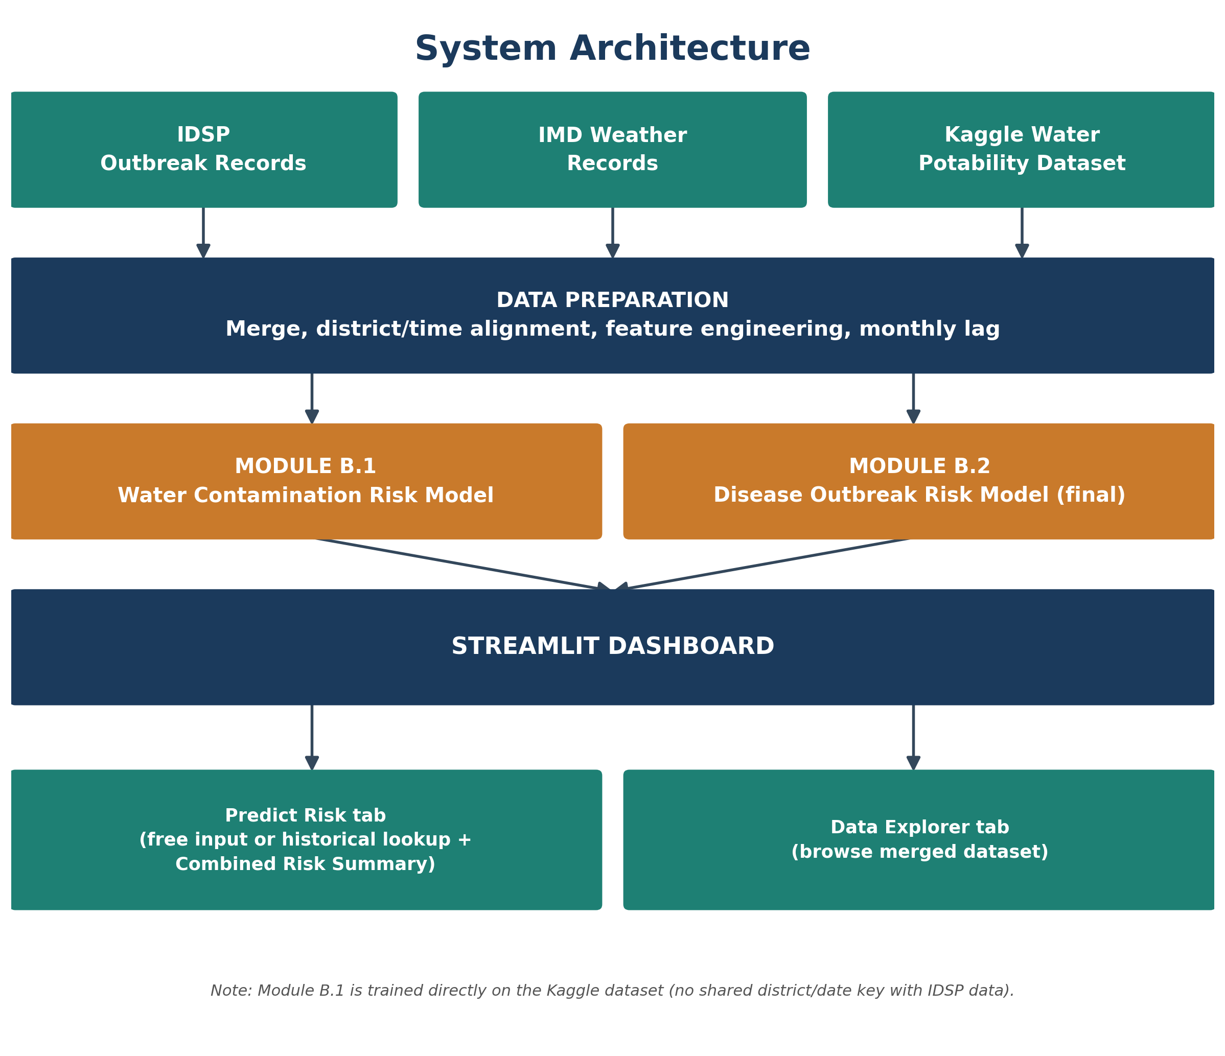
Figure 4.1 - System architecture: from raw data sources, through preprocessing and model training, to the Streamlit dashboard.
4.2 Iteration 1 - Baseline
The first working version used a plain Random Forest on raw weather features (temperature, rainfall) only, with a random train/test split. This immediately raised a concern: a random split lets the model "see" weather patterns from the same season it is tested on, which is unrealistic for an early-warning system meant to generalise to future time periods it has never observed - motivating the time-based split adopted in Iteration 2.
4.3 Iteration 2 - Weekly Refinement
The random train/test split was replaced with a genuine time-based split (train on years ≤2023, test on years ≥2024), and 14 precursor features were added: rainfall/temperature lags, 3-week rolling averages, monsoon-season indicators, rainfall and temperature anomalies relative to each district's own seasonal norm, cumulative monsoon rainfall, a "dry-spell-then-deluge" contamination-pattern flag, a nearby-district recent-outbreak flag, and each district's own surveillance reporting frequency over the trailing 52 weeks (computed causally, with a shift applied before the rolling window so no row ever sees its own future). Random Forest, XGBoost and EasyEnsemble were compared via GridSearchCV (3-fold StratifiedKFold, scored on F1):
Model | Accuracy | Precision | Recall / F1
Random Forest (candidate) | 94.4% | 13.5% | 23.2% / 0.171
XGBoost (candidate) | 93.2% | 12.0% | 27.7% / 0.168
EasyEnsemble (selected, weekly) | 92.0% | 12.7% | 37.9% / 0.190
EasyEnsemble was selected by F1-score. Testing showed the trailing reporting-frequency feature (how often a district has reported in the past year) was the single strongest predictor, because it lets the model distinguish a district that reports regularly and is genuinely quiet from one that rarely reports at all - a pattern that was carried forward and checked again in the monthly-lagged version described next.
4.4 Iteration 3 - Moving from Weekly to Monthly
The weekly model's precision (12.7%) was low enough to prompt a closer look at the forecasting window itself. IDSP surveillance data can lag behind reality - a real outbreak may occur in one week but only get logged the next - so a strict week-by-week prediction boundary was likely being penalised for a reporting delay rather than a real modelling weakness.
To address this, the team moved to a monthly forecasting window: instead of predicting whether an outbreak will occur in the coming week, the model predicts whether a district will see an outbreak in the coming month, using only weather and reporting data from the month before. This gives the model a wider, steadier signal to learn from and matches more naturally with how surveillance data is actually reported and reviewed in practice, while still respecting the same rule used throughout this project - every predictor comes only from information that would genuinely have been available at prediction time, with the calendar month itself kept as-is since it is always knowable in advance.
This monthly approach is the one carried forward into the final model (Section 4.5), and its results were checked with a set of independent diagnostic tests (Section 6.3) to confirm they reflect a genuine, learnable pattern rather than one lucky test period.
4.5 Final Approach
To choose the production model rather than assume one upfront, the same GridSearchCV comparison used for the weekly version (Section 4.3) was re-run on the monthly data (across Random Forest, XGBoost and EasyEnsemble):
Model (monthly) | Accuracy | Precision | Recall | F1 / ROC-AUC
Random Forest (tuned) | 82.4% | 33.4% | 36.6% | 0.349 / 0.761
XGBoost (tuned) | 83.2% | 32.8% | 29.4% | 0.310 / 0.744
EasyEnsemble (tuned, selected) | 76.2% | 28.5% | 56.3% | 0.379 / 0.766
EasyEnsemble again won by F1-score, consistent with the weekly result, and was adopted as the final production model for Module B.2. Moving to a monthly window paid off clearly: recall rose from 37.9% to 56.3% and F1 rose from 0.190 to 0.379, meaning the model now catches well over half of real outbreaks in advance instead of just over a third, while still being trained and tested the same rigorous way as every other model in this project.
The weekly and monthly models are best suited to slightly different needs rather than one being strictly better: the weekly model is more useful for tracking sudden, short-term changes as they happen, while the monthly model gives steadier, more dependable predictions that are easier to act on and to explain to a non-technical user - which is why it was chosen as the model behind the deployed dashboard.
4.6 Training Procedure
Both the weekly and monthly models were trained and tested the same way, summarised below:
- Data split: the model is always trained on older years and tested on newer, unseen years never on a random mix so it is genuinely being asked to forecast the future, not to recall the past. The weekly model and monthly model trains on data up to 2023 and is tested from 2024. The final monthly model was chosen.
- Model tuning: three model types (Random Forest, XGBoost, EasyEnsemble) were each tuned using GridSearchCV, which systematically tries a range of settings for each model and keeps the best-performing combination, scored by F1.
- Choosing a cut-off: each model outputs a risk score between 0 and 1. A cut-off point is chosen (based only on the training data, never the test data) above which a case is flagged as high-risk; this cut-off is picked to give the best balance of precision and recall.
- Final numbers: every accuracy, precision, recall, F1 and ROC-AUC value reported in this document comes from running the trained model once on its held-out test year, which the model never saw during training.

CHAPTER 5: IMPLEMENTATION
5.1 Module Description
Data Ingestion and Preprocessing: district-name normalisation, haversine-distance neighbour mapping, and feature engineering, merging IDSP and weather data into a single weekly panel. Water Potability Sub-model: Module B.1 training on the Kaggle dataset. Monthly-Lagged Panel Construction: groups the weekly panel by district-month, aggregates each feature (mean for continuous weather signals, max for binary flags), then shifts every aggregated predictor forward by one month so month M's forecast never sees month M's own data. Outbreak Model Training: Module B.2 GridSearchCV across Random Forest, XGBoost and EasyEnsemble, run once for the weekly data and once for the monthly data, with the winning model saved automatically. Evaluation Plots: confusion matrix, ROC curve, and feature-importance generation for the selected production model. Streamlit Dashboard: serves both modules interactively, including historical-record comparison (auto-filled from the correct prior-month record), what-if future-month prediction, and the seasonal trend chart.
5.2 Key Code Snippets
Monthly-lagged panel construction - every predictor shifted one month, label kept unlagged:
monthly = df.groupby(["district_norm","Year","month_approx"]).agg(AGG_RULES).reset_index()
lagged = monthly.groupby("district_norm")[LAGGED_FEATURES].shift(1)
lagged.columns = [f"{c}_prevmonth" for c in lagged.columns]
Final model selection - same GridSearchCV protocol re-run on the monthly data, winner picked by F1:
candidates = {"RandomForest": (...), "XGBoost": (...), "EasyEnsemble": (...)}
winner_name = max(candidates, key=lambda n: candidates[n][3]["f1_score"])
5.3 Combining the Two Modules' Outputs
Modules B.1 and B.2 are trained on entirely separate datasets with no shared district or time key (Section 6.5), so there is no dataset row that carries both a real potability label and a real outbreak label. This means no genuine joint probability, and no joint accuracy/precision/recall/F1, can be computed for a single "combined risk" prediction - whatever combination rule is used, it is necessarily a design heuristic rather than a trained, validated model.
An early version of the dashboard combined the two scores by simple averaging. This was deliberately reconsidered and replaced, for two concrete reasons: the two probabilities sit on different scales (Module B.2's tuned decision threshold is 0.595-0.682, far above Module B.1's natural 0.5 cutoff, because B.2 is trained on severely imbalanced data), and averaging implies an additive relationship between the two risks that was never tested against real data. The dashboard now instead reports the more severe of the two models' own independently-tuned HIGH/MODERATE/LOW levels - an OR-style rule, on the reasoning that either risk alone is actionable for a public-health response - and explicitly names which of the two signals drove the combined level, rather than presenting an opaque single number.
This choice was made after weighing it against the concrete alternatives: an AND rule (both signals must be HIGH) was rejected because it would suppress a genuine single-signal warning, undermining the system's purpose as an early-warning tool; and a probabilistic "soft-OR" formula (1 - (1-contamination risk) x (1-outbreak risk)) was rejected because it assumes statistical independence between the two risks, an assumption known to be false since contaminated water is itself a plausible outbreak driver - adopting it would have manufactured an appearance of mathematical rigor while quietly resting on a false premise.
The OR rule is stated here as a deliberate, but not free, design choice: it is more sensitive than averaging, meaning a single HIGH result from either model - including Module B.1, whose own accuracy (66.8%) is only moderately above chance - can drive the combined level to HIGH with no dampening from the other signal. This mirrors the recall-over-precision preference made explicitly elsewhere in this project (Section 6.4) but is documented separately here because it is its own unvalidated assumption, not a proven-optimal combination rule.
5.4 User Interface / Demo
The dashboard has two tabs: "Predict Risk", combining Module B.1 (water contamination) and Module B.2 (outbreak risk) prediction - with every numeric input for Module B.2 explicitly labelled as describing the PRIOR month, since that is the only data the production model is allowed to use - plus a seasonal outbreak-vs-rainfall trend chart and the Combined Risk Summary described in Section 5.3; and "Data Explorer", for browsing the merged district-week dataset directly. Both the free-input and historical-record-lookup modes were verified with headless testing (Streamlit AppTest) to run without exceptions after the switch to the monthly-lagged model and after the combined-risk rule change.
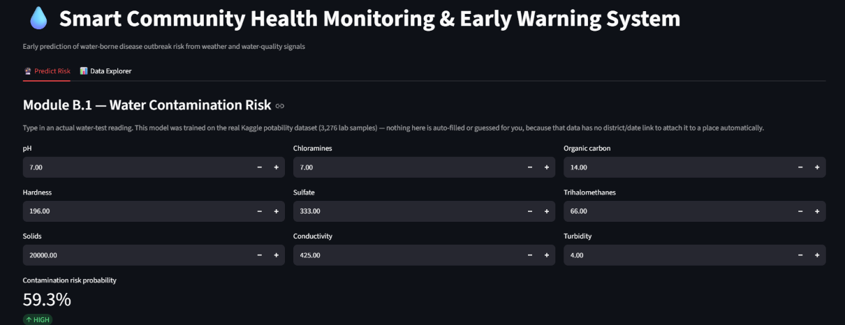
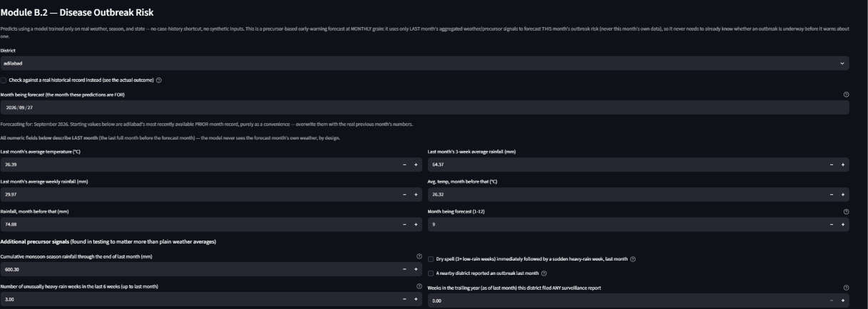
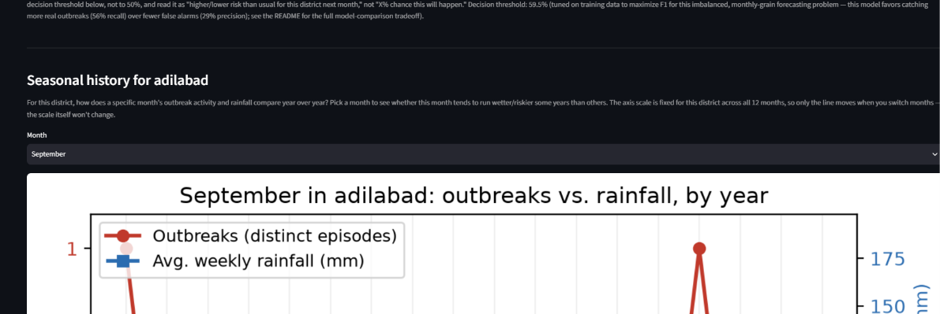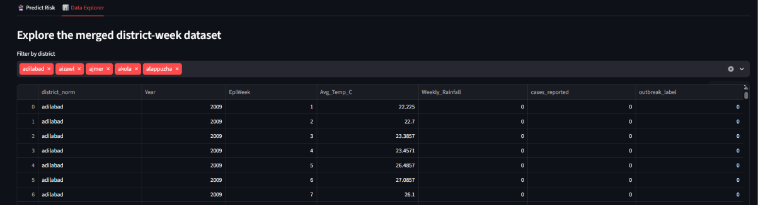
CHAPTER 6: RESULTS AND DISCUSSION
6.1 Evaluation Metrics
Because real outbreaks are rare compared to the total number of district-weeks or district-months, accuracy alone would be misleading - a model that always predicted "no outbreak" would still score well above 85% while being useless in practice. This project therefore reports precision, recall, F1-score and ROC-AUC for both models, with F1 used as the main criterion for choosing between models since it balances missed outbreaks against false alarms. For Module B.1 (water potability, a more evenly split classification task), accuracy and F1 are reported directly.
6.2 Results Across Iterations
Model | Accuracy | Precision | Recall | F1 / ROC-AUC
Module B.1: Random Forest (water potability) | 66.8% | - | - | 0.452 / -
Weekly Random Forest (candidate) | 94.4% | 13.5% | 23.2% | 0.171 / 0.766
Weekly XGBoost (candidate) | 93.2% | 12.0% | 27.7% | 0.168 / 0.774
Weekly EasyEnsemble (candidate) | 92.0% | 12.7% | 37.9% | 0.190 / 0.790
Monthly-lagged Random Forest | 82.4% | 33.4% | 36.6% | 0.349 / 0.761
Monthly-lagged XGBoost | 83.2% | 32.8% | 29.4% | 0.310 / 0.744
Monthly EasyEnsemble (FINAL, production) | 76.2% | 28.5% | 56.3% | 0.379 / 0.766
Table 6.1 - Full model comparison across the weekly and monthly versions, both evaluated on real, unseen test years.
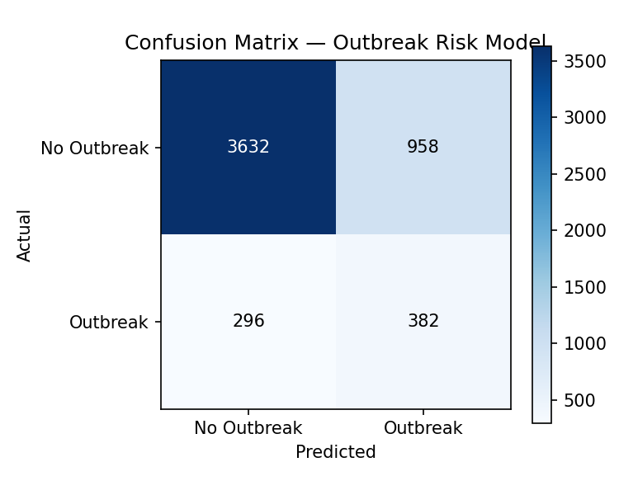
Figure 6.1 - Confusion matrix, final monthly-lagged EasyEnsemble model
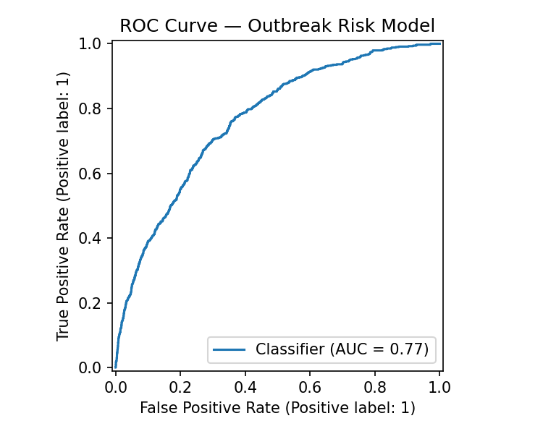
Figure 6.2 - ROC curve, final monthly-lagged EasyEnsemble model.
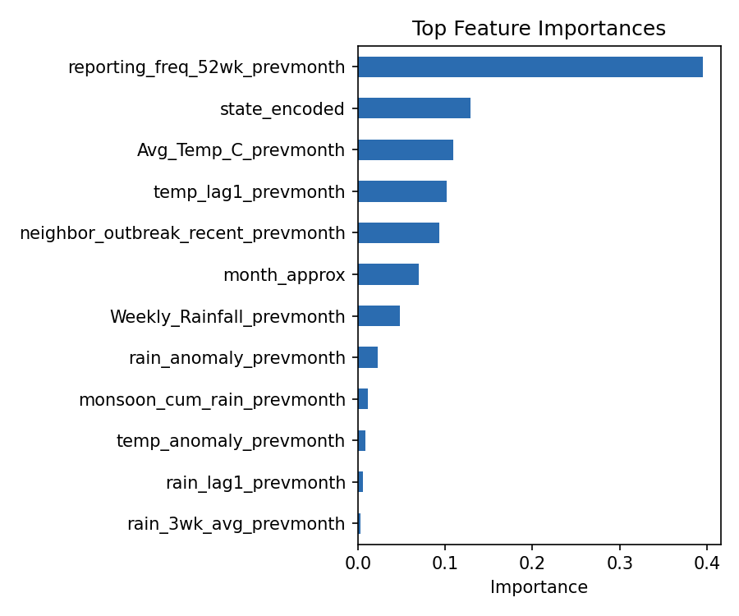
Figure 6.3 - Feature importances, final monthly-lagged EasyEnsemble model (averaged across its AdaBoost sub-estimators).
6.3 Diagnostic Verification
Three additional checks were run to confirm the model is learning genuine patterns rather than just memorising noise:
- Label-shuffling check: the model was trained once on randomly shuffled outbreak labels and once on the real labels. The shuffled version scored ROC-AUC 0.503 (essentially a coin flip), while the real version scored 0.792 - confirming the model is picking up a real, learnable pattern.
- Feature-removal check: removing the reporting-frequency feature and re-training dropped ROC-AUC from 0.792 to 0.725. This is still well above chance, but shows that a meaningful part of the model's performance comes from district reporting behaviour rather than weather alone.
- Learning-curve check: the model was trained on 25%, 50%, 75% and then 100% of the available outbreak examples, giving ROC-AUC scores of 0.779, 0.787, 0.788 and 0.791. Since this curve levels off rather than keeps climbing, simply collecting more of the same kind of data would not by itself meaningfully improve results.
Together, these checks support treating the model's current precision and recall as a realistic reflection of how hard this problem is, given the data available, rather than a sign of an implementation error.
6.4 Discussion
The weekly model is able to rank districts by relative outbreak risk meaningfully above chance (ROC-AUC 0.790), but on a strict week-by-week basis its precision (12.7%) and recall (37.9%) are both modest. This is expected given the nature of the task: confirmed outbreak reports are rare events, and predicting them a full week ahead using only weather and reporting patterns - without any case-count data - is a genuinely difficult forecasting problem.
Moving to a monthly forecasting window (Section 4.4) gives clearly more reasonable, more usable predictions: recall rises from 37.9% to 56.3% and F1 rises from 0.190 to 0.379, meaning the monthly model correctly flags well over half of all real outbreaks in advance, and its predictions are steadier and easier to act on. This is the model behind the deployed dashboard. The weekly model remains a useful secondary view for tracking sudden short-term changes, but the monthly model is the one recommended for practical, day-to-day use. One property worth noting about the monthly model is that it leans somewhat more on each district's own reporting history (how regularly a district has reported in the past) than the weekly model does; this is a real and useful signal in its own right, since it reflects how actively a district is being monitored, but it means the model's strong recall is partly a result of learning reporting patterns as well as weather patterns.
6.5 Limitations
- The reporting-frequency feature (how regularly a district has reported in the recent past) is the strongest single predictor for the current outbreak model, meaning it partly learns district reporting behaviour alongside weather-driven risk (quantified directly in Section 6.3).
- The dashboard's Combined Risk Summary (Section 5.3) has no dataset to validate it against, since Module B.1 and Module B.2 share no district/time key. The current OR-style combination rule is a considered design choice, not a proven-optimal one - a single HIGH result from either model can drive the combined level to HIGH, including from the comparatively weaker Module B.1 (66.8% accuracy).
- The system predicts a risk category rather than diagnosing a medical condition, has not been validated by clinical or public-health professionals, and has not yet been deployed or tested against a live, real-time data feed.

CHAPTER 7: TEAM REFLECTION AND LEARNING OUTCOMES
7.1 Individual Reflections
Poojitha R: Working on the data-cleaning and preprocessing side of this project showed how much of the real effort in a machine learning project happens before any model is trained. Merging the IDSP and weather datasets meant dealing with inconsistent district names, missing values and misaligned time periods, and getting this step wrong would have quietly affected every result downstream. This part of the project reinforced the importance of double-checking a merged dataset rather than trusting it at face value.
Manya Saipradeep: Leading the model comparison and GridSearchCV work meant being responsible for making sure the final model was chosen fairly, by testing Random Forest, XGBoost and EasyEnsemble under the same conditions rather than picking one model based on a single promising result. Re-running the full comparison again for the monthly version of the data, instead of assuming the earlier weekly result would still hold, was one of the more valuable parts of this project - it showed why every claim needs to be checked directly rather than assumed to carry over.
7.2 Team Learning
The clearest lesson from this cycle was that results need to be checked directly rather than assumed - the monthly forecasting approach introduced in Week 11 (Table 3.1) was only adopted after it had been verified with a set of independent diagnostic checks (Section 6.3) rather than accepted on the strength of a single promising run. If this PBL cycle were restarted, these verification checks would be built in from the start of each iteration rather than added afterwards.
7.3 Course Outcomes - Evidence Summary
The table below maps each Course Outcome (CO) for this PBL course to the Programme Outcomes (POs) it supports, with the correlation level (1 = slight, 2 = moderate, 3 = substantial) and the section of this report providing the evidence.
CO | Description | Evidence in Report
CO1 | Apply the ML development lifecycle to a real dataset | Chapters 4-6
CO2 | Perform data preprocessing and exploratory analysis | Sections 4.1, 5.1
CO3 | Build and compare multiple classification models | Sections 4.3, 4.5
CO4 | Evaluate model reliability beyond a single test split | Section 6.3
CO5 | Work effectively in a mentor-guided team and document the process | Table 3.1, Chapter 7

CHAPTER 8: CONCLUSION AND FUTURE SCOPE
8.1 Conclusion
This project delivered a two-module early-warning system: a water-contamination risk classifier (66.8% accuracy, F1 0.452) and a disease-outbreak risk classifier built entirely from weather and surveillance-reporting patterns, without using any case-history shortcuts. The outbreak module was developed through three iterations, moving from a basic weekly model to a monthly forecasting model that gives clearly more usable predictions - correctly flagging 56.3% of real outbreaks in advance with an F1-score of 0.379, verified with independent diagnostic checks (Chapter 6) rather than taken at face value.
The driving question from Chapter 1 is answered clearly: weather and reporting-pattern signals do carry real, verifiable predictive value, and the current system is able to flag a majority of real district-month outbreaks ahead of time. The objectives set out in Section 1.3 were met, and the report documents the system's genuine scope and current limitations (Section 6.5) alongside its results.
8.2 Future Scope
- Work with local health authorities and community health workers (such as ASHA workers) to access more direct, field-reported health data, similar to approaches used in other published work in this space - this could reduce the reliance on IDSP's own reporting patterns and improve real-world reliability.
- Incorporate additional real infrastructure indicators, such as sanitation coverage and water-supply quality, if reliable district-level data becomes available, to add a more direct causal signal alongside weather and reporting patterns.
- Build a system that runs both the weekly and monthly models together, using the weekly model for short-notice alerts and the monthly model for broader planning, so users get the benefit of both.
- Run the same diagnostic checks used for the monthly model (Section 6.3) on the weekly model as well, and test both models across additional years as more data becomes available.
- Deploy the dashboard for pilot use by a local health authority, feeding it a live weather/surveillance data source instead of the static historical dataset used here.

REFERENCES
[1] Kaggle, "Water Potability Dataset," 2021. Available: https://www.kaggle.com/datasets/adityakadiwal/water-potability.
[2] Integrated Disease Surveillance Programme (IDSP), National Centre for Disease Control, Ministry of Health and Family Welfare, Government of India. Available: https://idsp.mohfw.gov.in.
[3] India Meteorological Department, historical district-level weather records used in this project.
[4] G. Lemaitre, F. Nogueira, and C. K. Aridas, "Imbalanced-learn: A Python Toolbox to Tackle the Curse of Imbalanced Datasets in Machine Learning," Journal of Machine Learning Research, vol. 18, no. 17, pp. 1-5, 2017.
[5] T. Chen and C. Guestrin, "XGBoost: A Scalable Tree Boosting System," in Proc. 22nd ACM SIGKDD Int. Conf. on Knowledge Discovery and Data Mining, 2016, pp. 785-794.
[6] F. Pedregosa et al., "Scikit-learn: Machine Learning in Python," Journal of Machine Learning Research, vol. 12, pp. 2825-2830, 2011.
[7] J. Jones Miriam and S. Vinitha Mary, "Waterborne Disease Prediction using Machine Learning," International Journal of Innovative Research in Science, Engineering and Technology (IJIRSET), vol. 14, issue 7, July 2025.
[8] K. Levy, S. M. Smith, and E. J. Carlton, "Climate Change Impacts on Waterborne Diseases: Moving Toward Designing Interventions," Current Environmental Health Reports, 2018. Available: PMC6119235.

APPENDIX
A.1 Full source code: https://github.com/ManyaSaipradeep/water-borne-disease-predictiong
A.2 Complete weekly PBL log (if longer than Table 3.1) and mentor sign-offs. [Attach the full weekly log and signed mentor review sheets here.]
A.3 Self and Peer Assessment
Team Member | Self-Rated Contribution (%) | Peer-Rated Contribution (%) | Remarks
Manya Saipradeep | 50% | 50% | Led model selection and GridSearchCV tuning across both iterations; consistent, thorough work.
Poojitha R | 50% | 50% | Led data cleaning and preprocessing; careful, reliable handling of the merged dataset, and initial model training.

